Year 10A |  | Non Linear Equations | Non Calculator
- Graph simple nonlinear relations with and without the use of digital technologies and solve simple related equations (ACMNA296)  - Solve simple quadratic equations using a range of strategies (ACMNA241)  - 10 A Solve simple exponential equations (ACMNA270)  10A Factorise monic and nonmonic quadratic expressions and solve a wide range of quadratic equations derived from a variety of contexts (ACMNA269) |  |  | Name_________________
Section 1 Short Answer Section
Write all working and answers in the spaces provided on this test paper.

Find the values of m for which 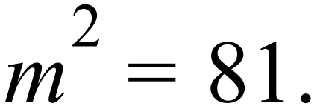

……………………………………………………………………………………………….

……………………………………………………………………………………………….
Solve the equation 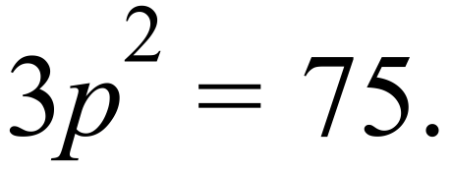

……………………………………………………………………………………………….

……………………………………………………………………………………………….
For what values of w is 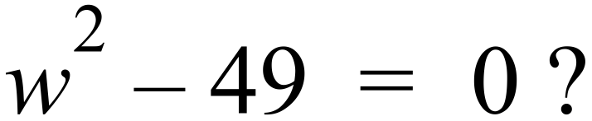

……………………………………………………………………………………………….

……………………………………………………………………………………………….
For what values of p is 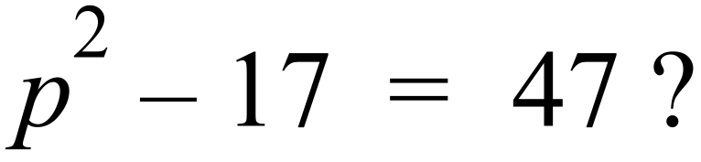

……………………………………………………………………………………………….

……………………………………………………………………………………………….
Solve for w: 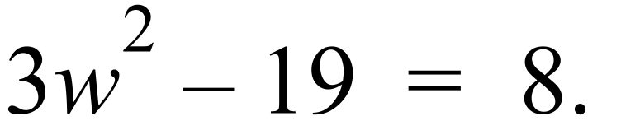

……………………………………………………………………………………………….

……………………………………………………………………………………………….
Solve 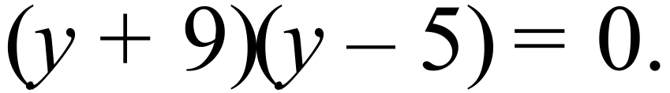

……………………………………………………………………………………………….

……………………………………………………………………………………………….
Solve the equation: 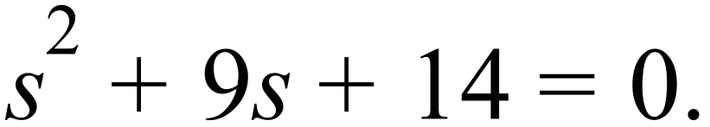

……………………………………………………………………………………………….

……………………………………………………………………………………………….
Solve : 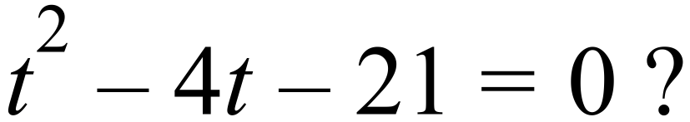

……………………………………………………………………………………………….

……………………………………………………………………………………………….
Solve 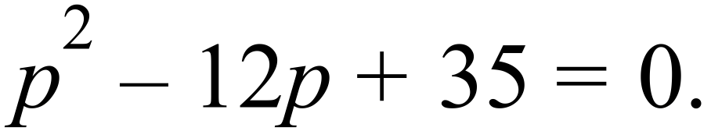

……………………………………………………………………………………………….

……………………………………………………………………………………………….
Solve 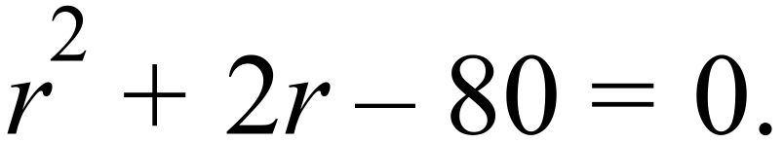

……………………………………………………………………………………………….

……………………………………………………………………………………………….
Solve 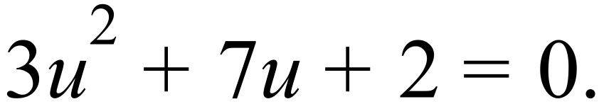

……………………………………………………………………………………………….

……………………………………………………………………………………………….

……………………………………………………………………………………………….
Solve 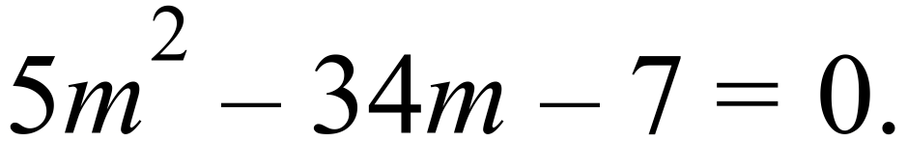

……………………………………………………………………………………………….

……………………………………………………………………………………………….

……………………………………………………………………………………………….
Give the exact values for which 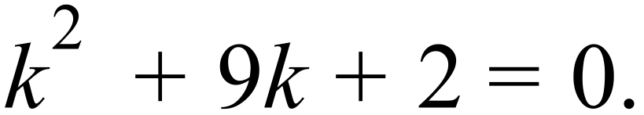

……………………………………………………………………………………………….

……………………………………………………………………………………………….

……………………………………………………………………………………………….
Find the solutions to 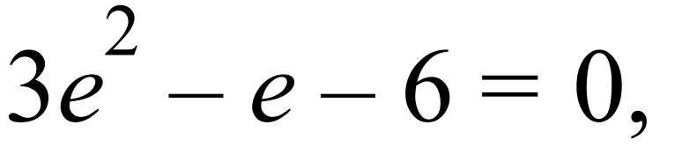 correct to two decimal places.

……………………………………………………………………………………………….

……………………………………………………………………………………………….

Determine how many solutions (if any) there are to the equation 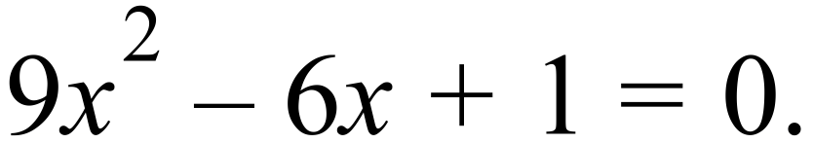
Explain your answer.

……………………………………………………………………………………………….

……………………………………………………………………………………………….

……………………………………………………………………………………………….
Make r the subject of 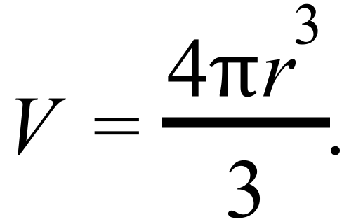

……………………………………………………………………………………………….

……………………………………………………………………………………………….

……………………………………………………………………………………………….

Year 10A |  | Non Linear Equations | Calculator Allowed
 |  | Non Linear Equations | Name_________________
Section 2 Multiple Choice Section
Mark all your answers on the accompanying multiple choice answer sheet, not on this test paper. You may do any working out on this test paper. Calculators are allowed for this section.

The solutions to 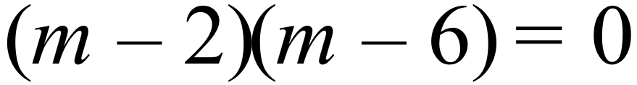 are:

A. 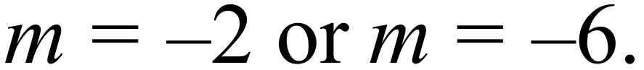 B. 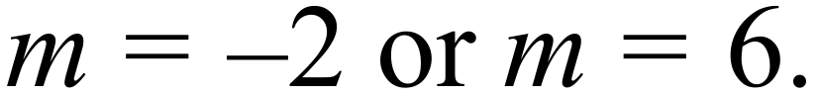
C. 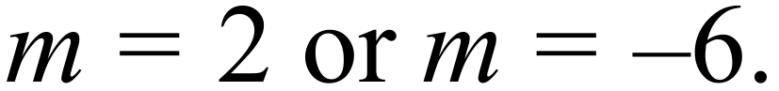 D. 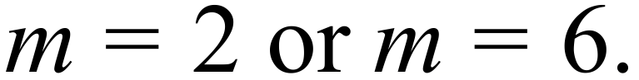
For what values of x is 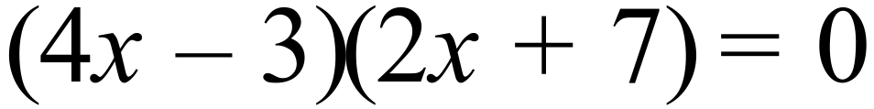?

A. 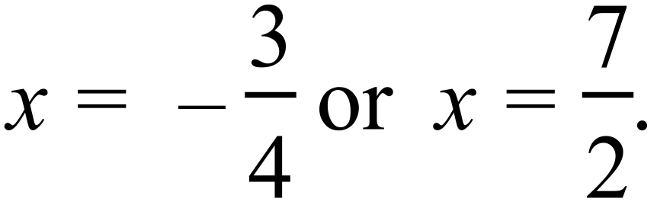 B. 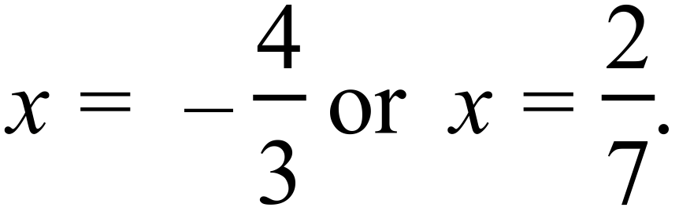
C. 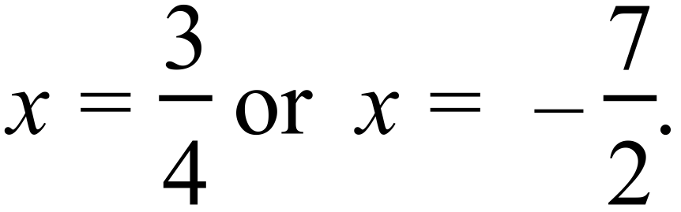 D. 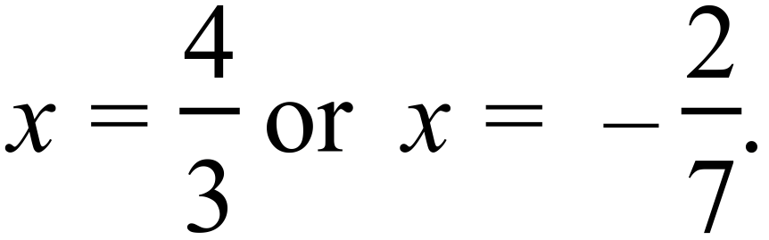
The solutions to 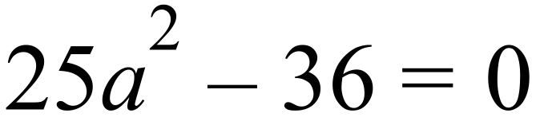 are:

A. 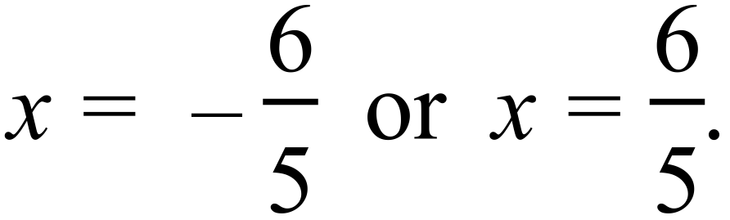 B. 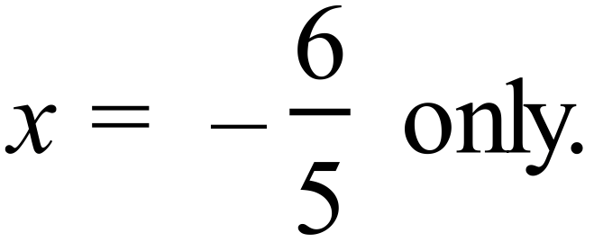
C. 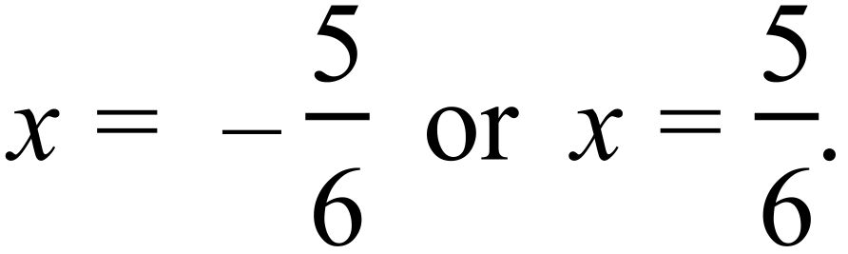 D. 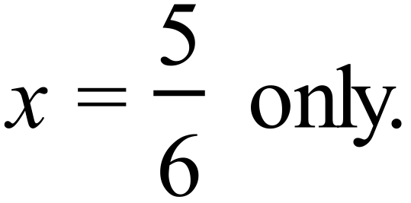
What are the solutions to 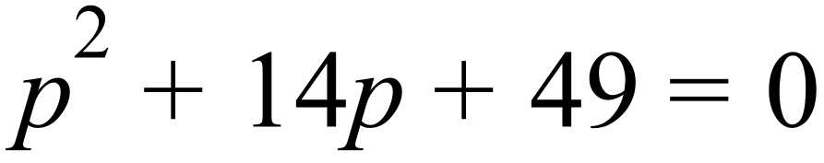?

A. 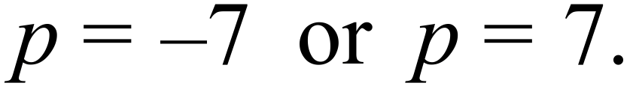 B. 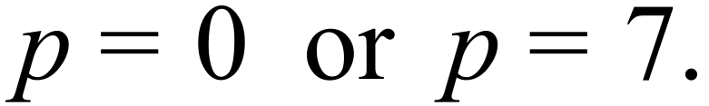
C. 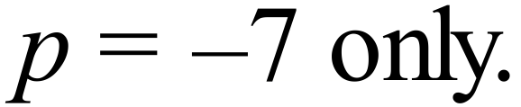 D. 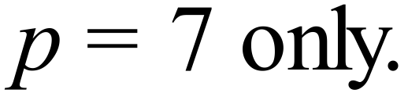
The solutions to 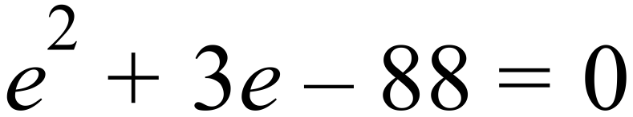 are:

A. 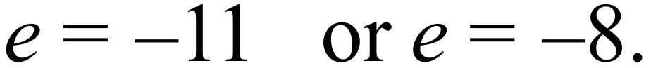 B. 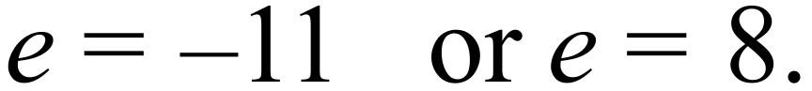
C. 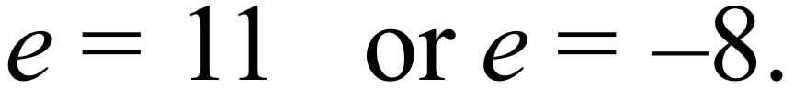 D. 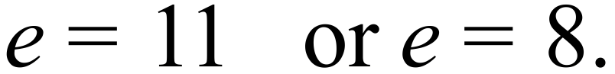
Solve 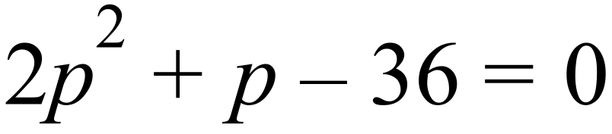.

A. 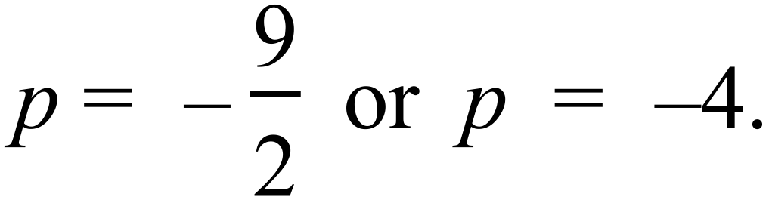 B. 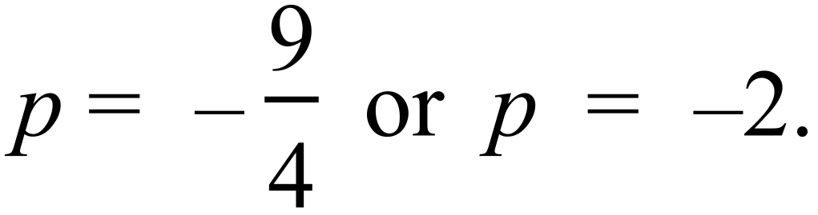
C. 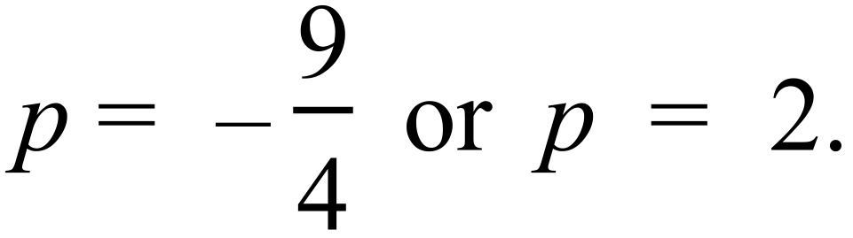 D. 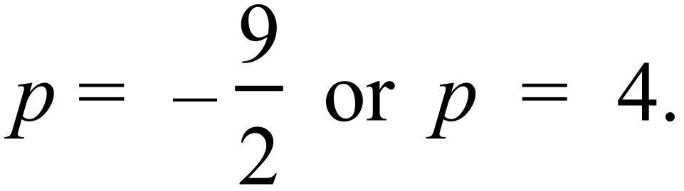
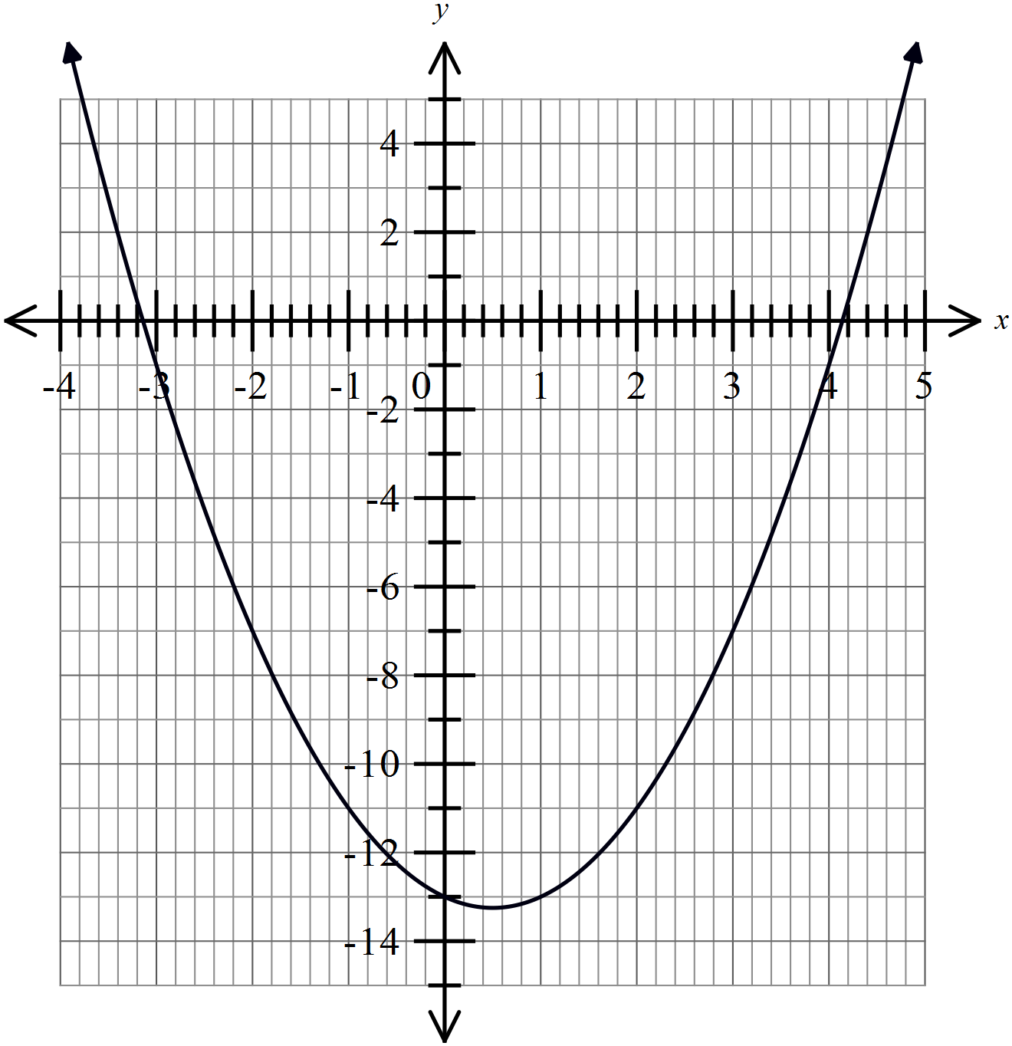The graph of 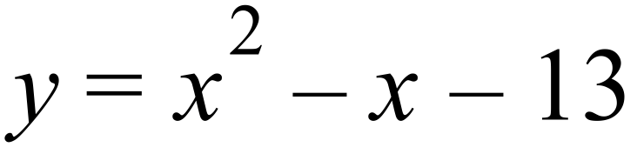 is shown.
Estimate the solution to 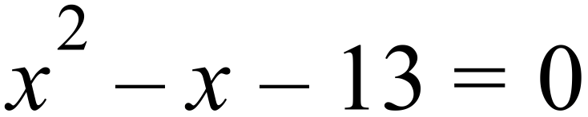

A.
B.
C.
D.

Find all the solutions to 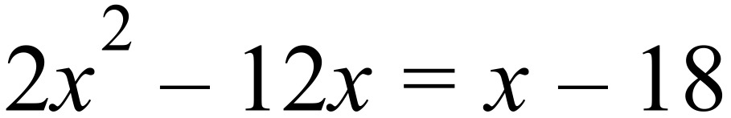

A. 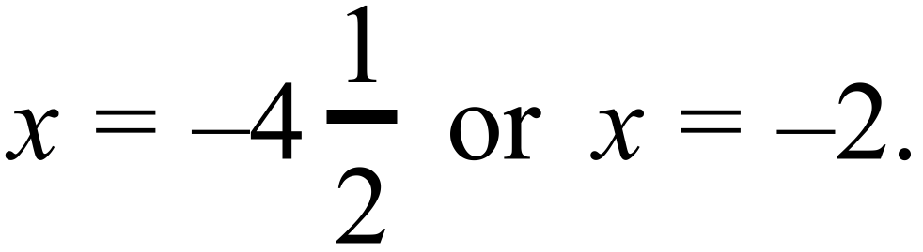 B. 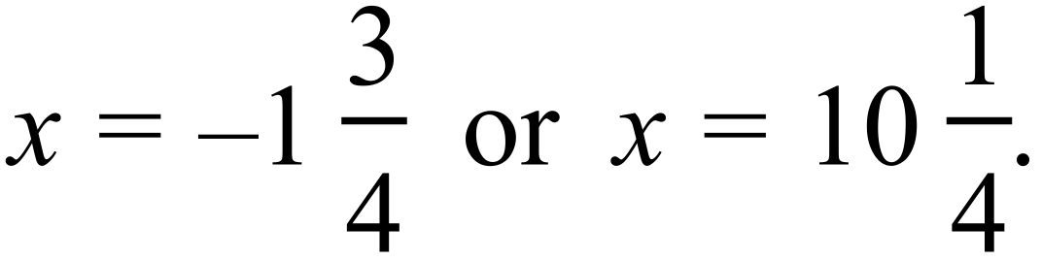
C. 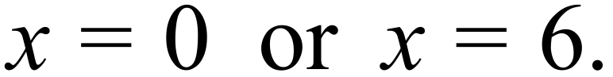 D. 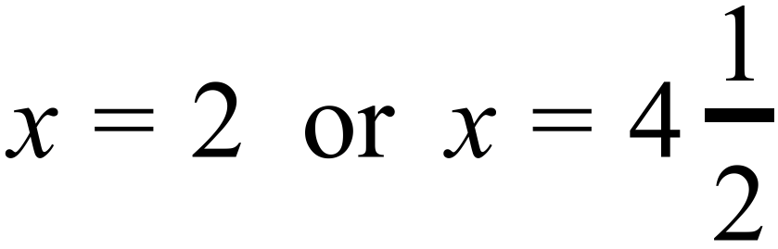
The solutions to 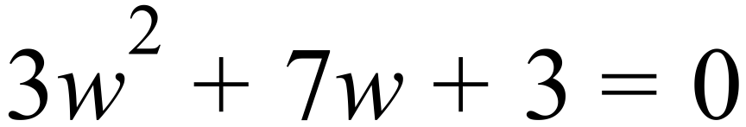 are:

A. 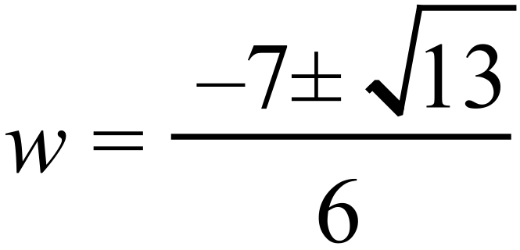 B. 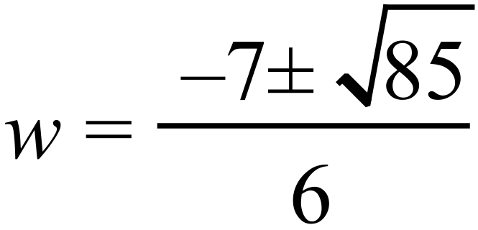
C. 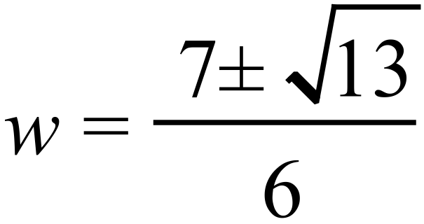 D. 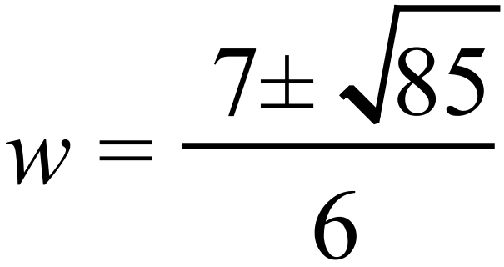
Solve 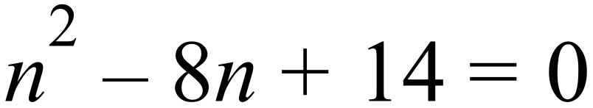.

A. 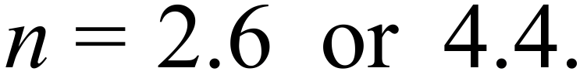 B. 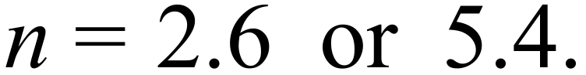
C. 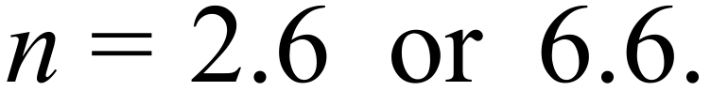 D. 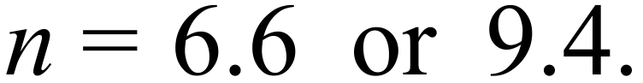
For what value of x is 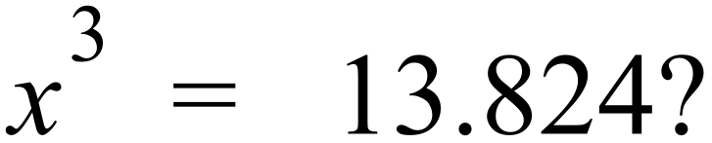

A. 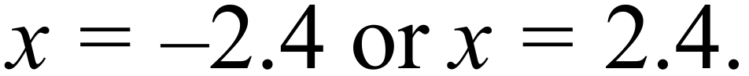 B. 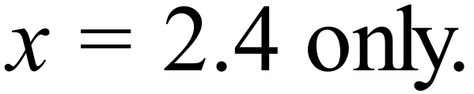
C. 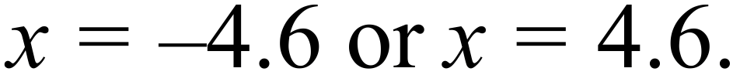 D. 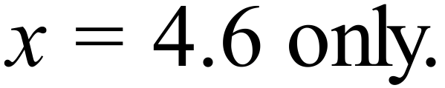
 | A. 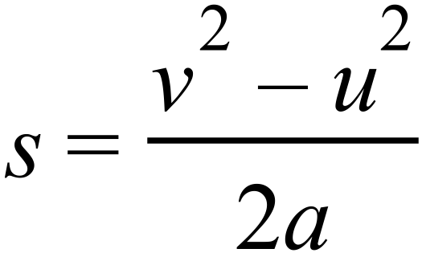 B. 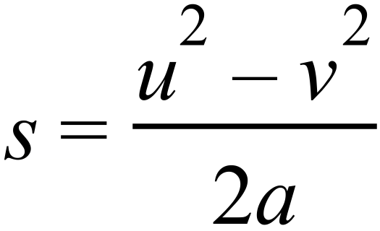 C. 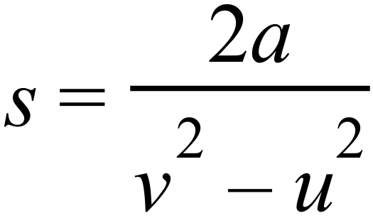 D. 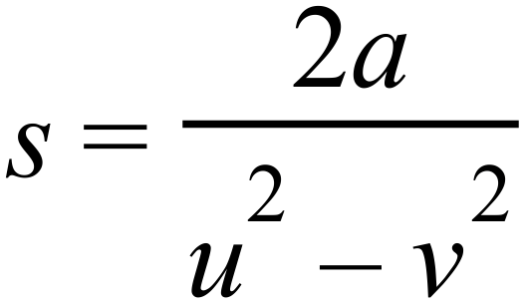

Year 10A | Non Linear Equations | Calculator Allowed
Year 10A | Non Linear Equations | Name___________________
Section 3 Longer Answer Section
Write all working and answers in the spaces provided on this test paper.

 |  | Marks
1. | (a) Solve 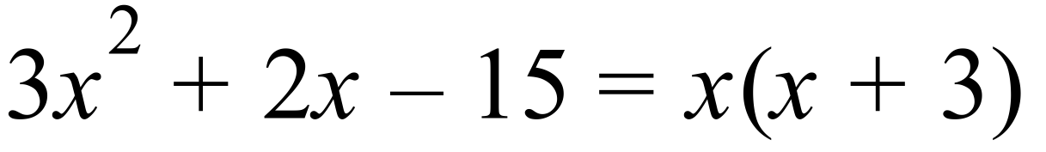  ……………………………………………………………………………………………….  ……………………………………………………………………………………………….  ……………………………………………………………………………………………… | 2
 | (b) Solve 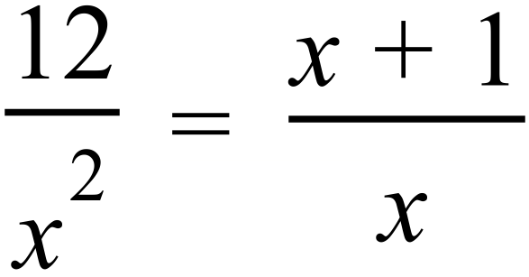 .  ……………………………………………………………………………………………….  ……………………………………………………………………………………………….  ……………………………………………………………………………………………… | 2
 | (c) A rectangle is to be drawn so that its length is 2.3 metres more than its width.  Its area is to be 12 m².  - Using w to represent the width, write expressions for the length and the area of the rectangle.  ……………………………………………………………………………………………….  - Write an equation using the area and solve it to find the length and width.  ……………………………………………………………………………………………….  ……………………………………………………………………………………………….  ………………………………………………………………………………………………  ………………………………………………………………………………………………. | 2  3
2. | Solve simultaneously  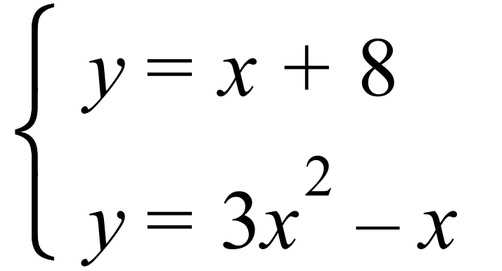  ……………………………………………………………………………………………….  ……………………………………………………………………………………………….  ………………………………………………………………………………………………  ………………………………………………………………………………………………. | 3

Multiple Choice Answer Sheet
Non Linear Equations
Name _____________________________________________
Completely fill the response oval representing the most correct answer.

1. A B C D
2. A B C D
3. A B C D
4. A B C D
5. A B C D
6. A B C D
7. A B C D
8. A B C D
9. A B C D
10. A B C D
11. A B C D
12. A B C D
Year 10A |  | Non Linear Equations | Non Calculator
Section 1 Short Answer Section
ANSWERS
No. | WORKING |  | ANSWER
 | 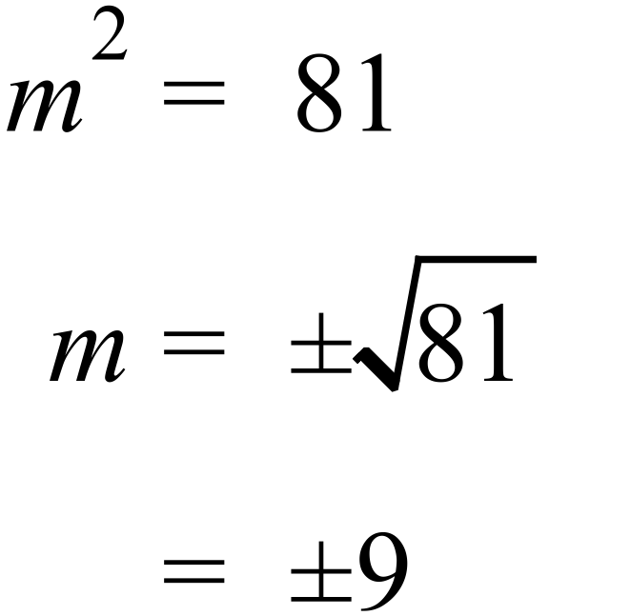 |  | 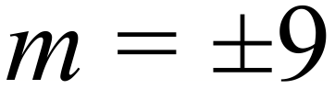
 | 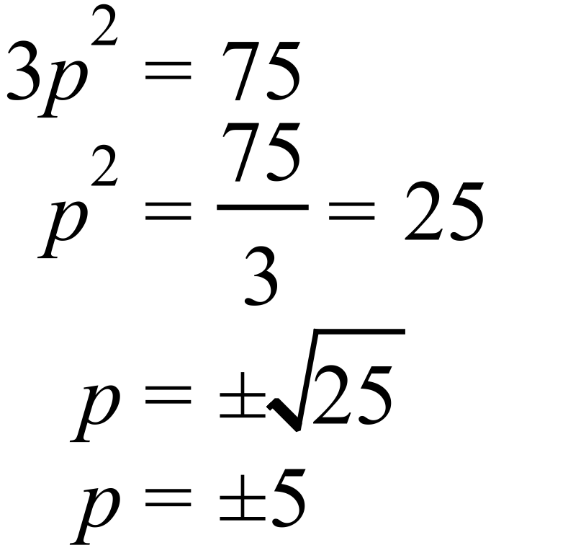 |  | 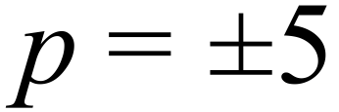
 | 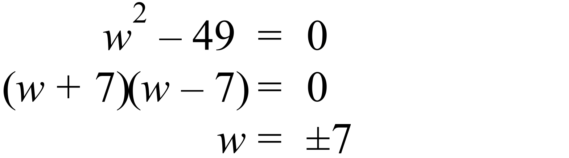 |  | 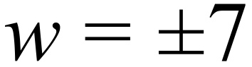
 | 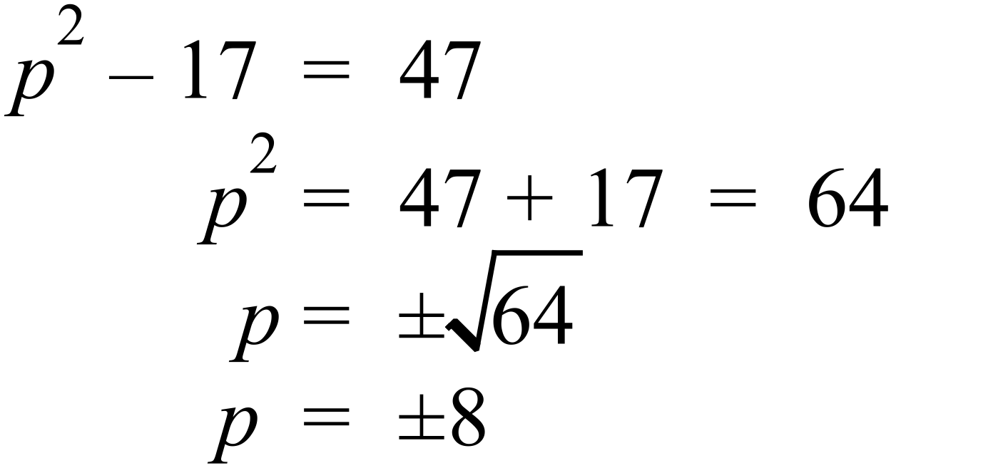 |  | 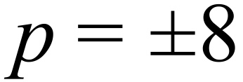
 | 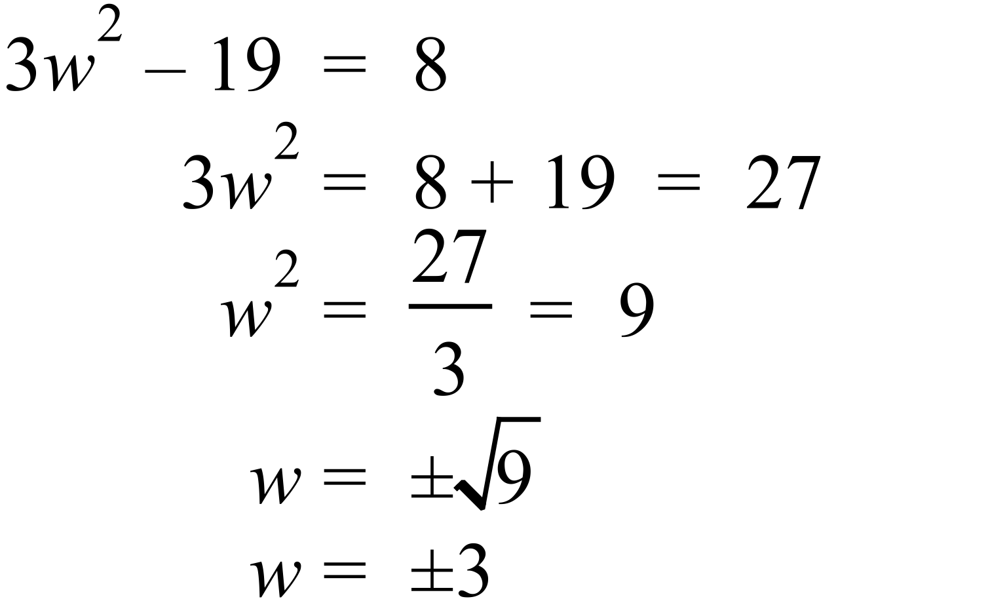 |  | 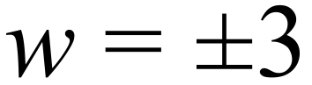
 | 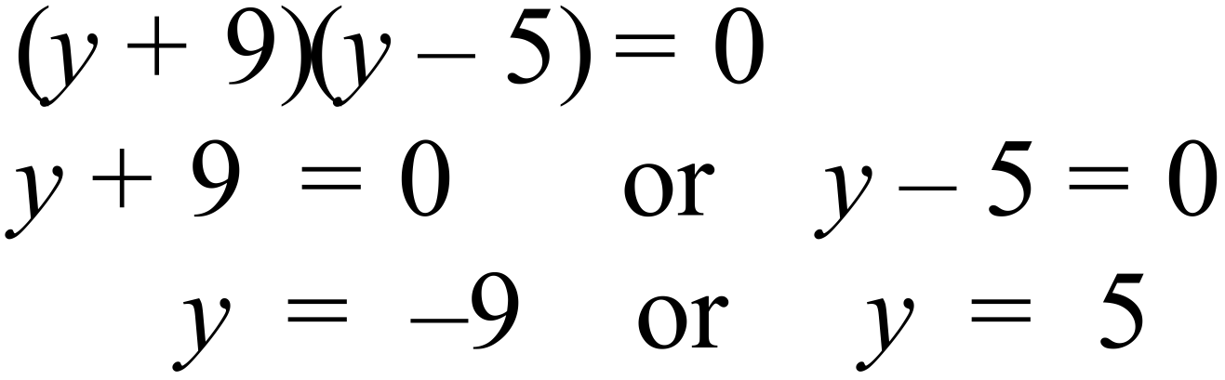 |  | 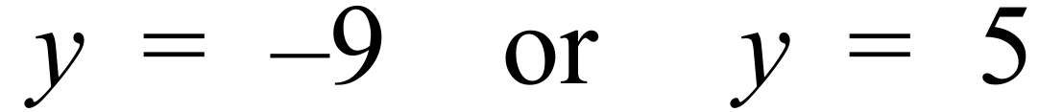
 | 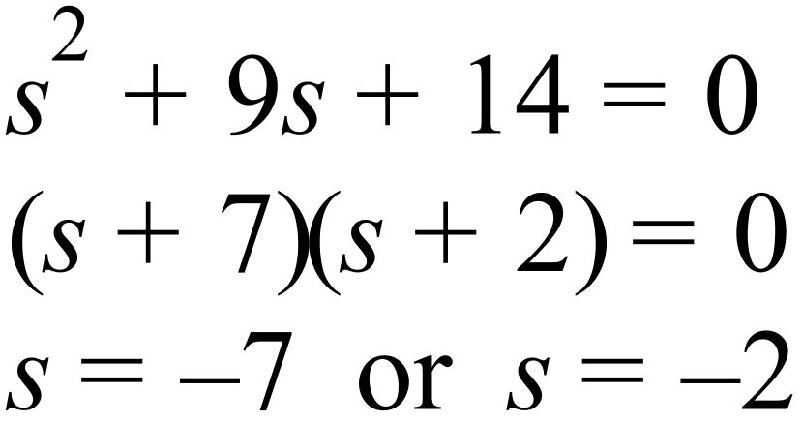 |  | 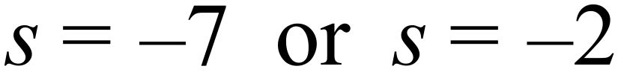
 | 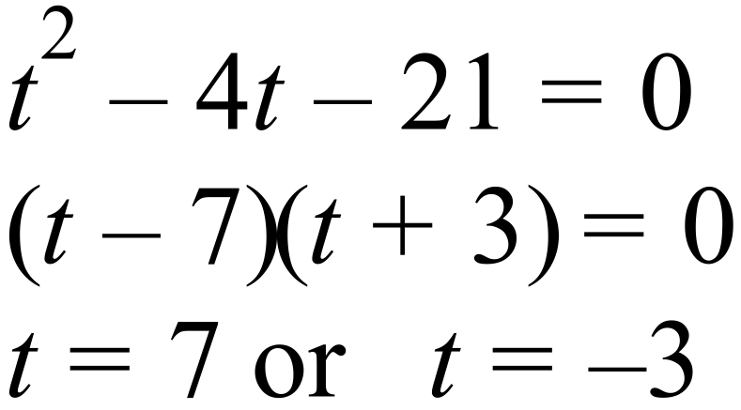 |  | 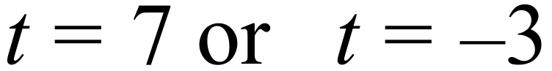
 | 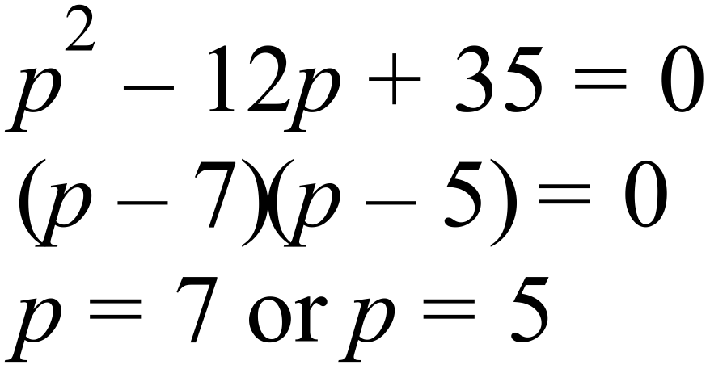 |  | 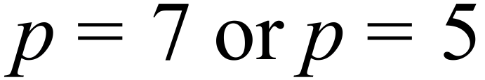
 | 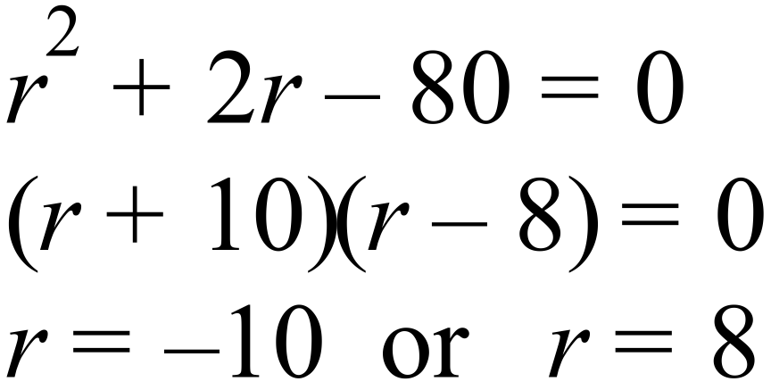 |  | 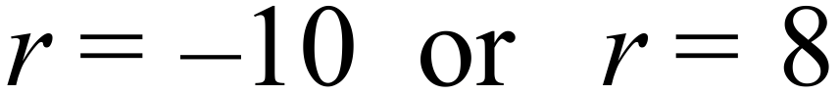
 | 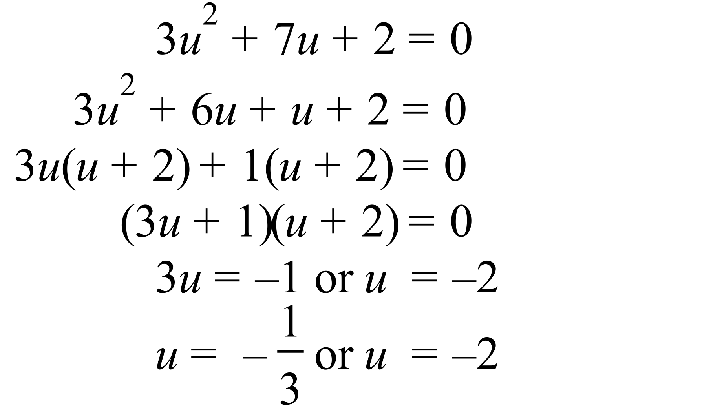 |  | 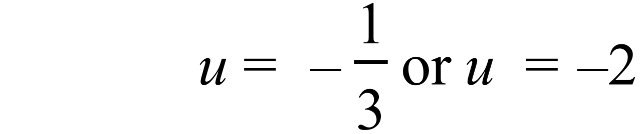
 | 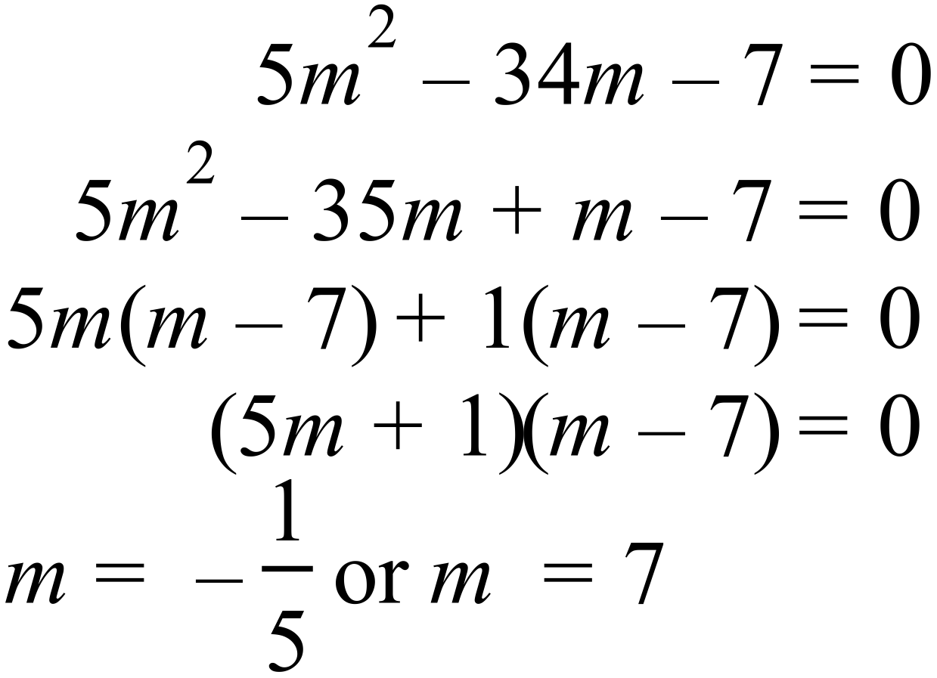 |  | 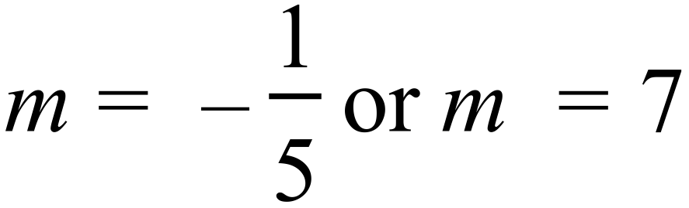
 | 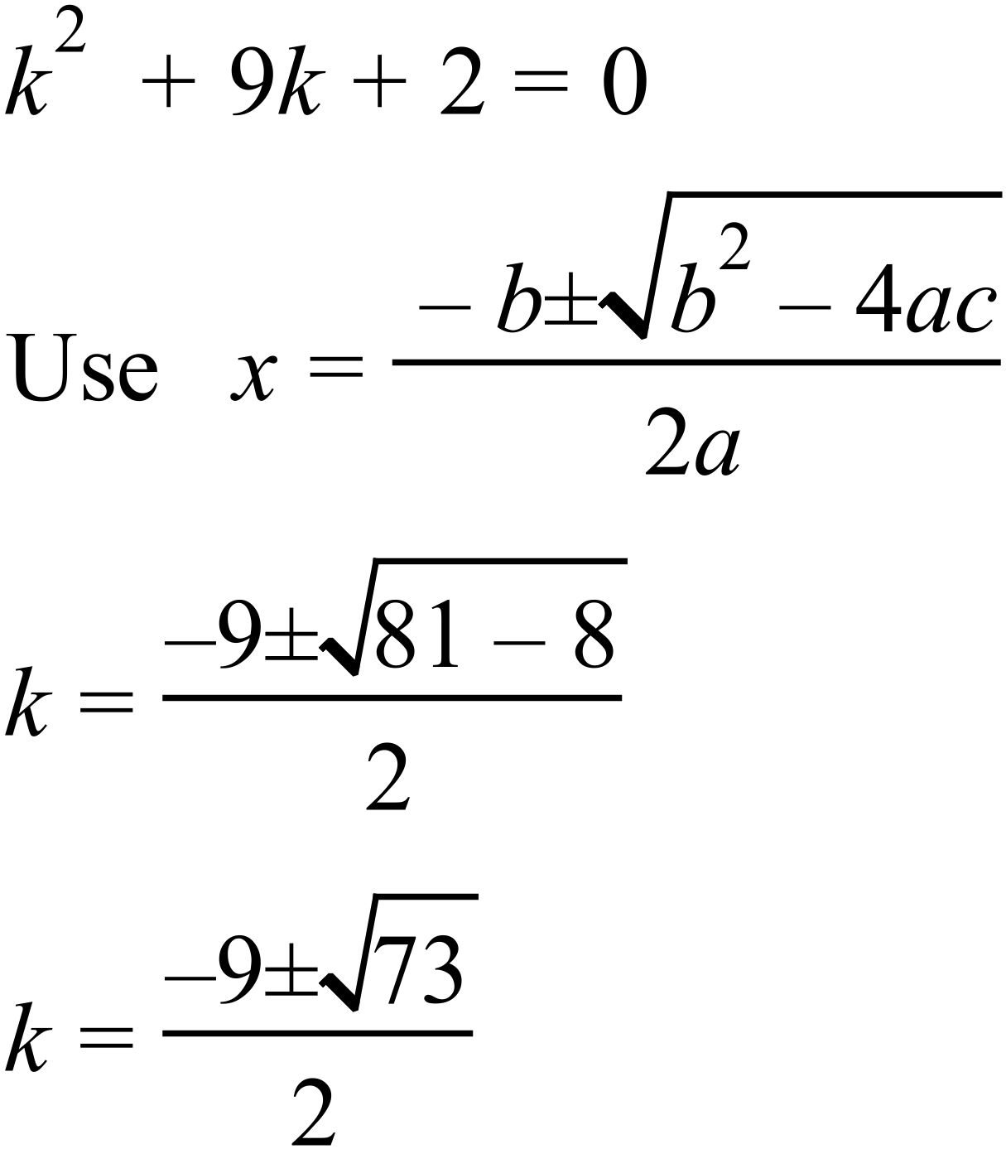 |  | 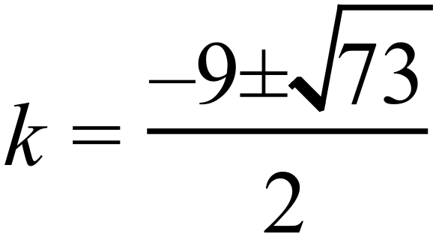
 | 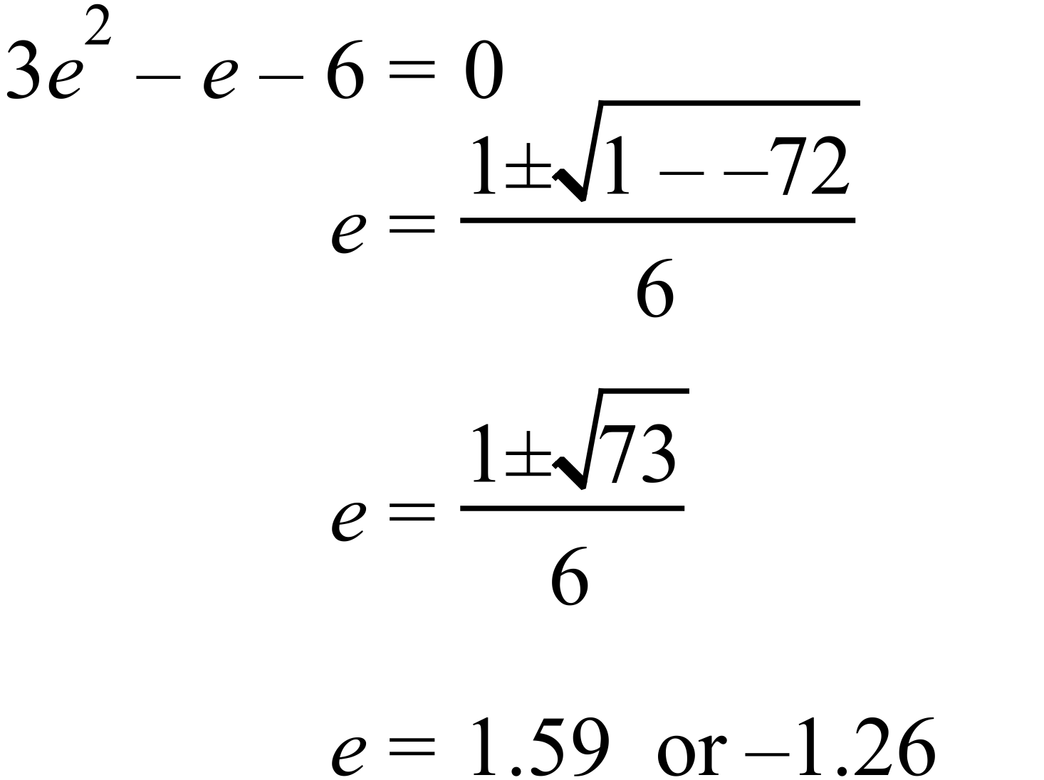 |  | 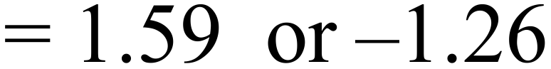
 | 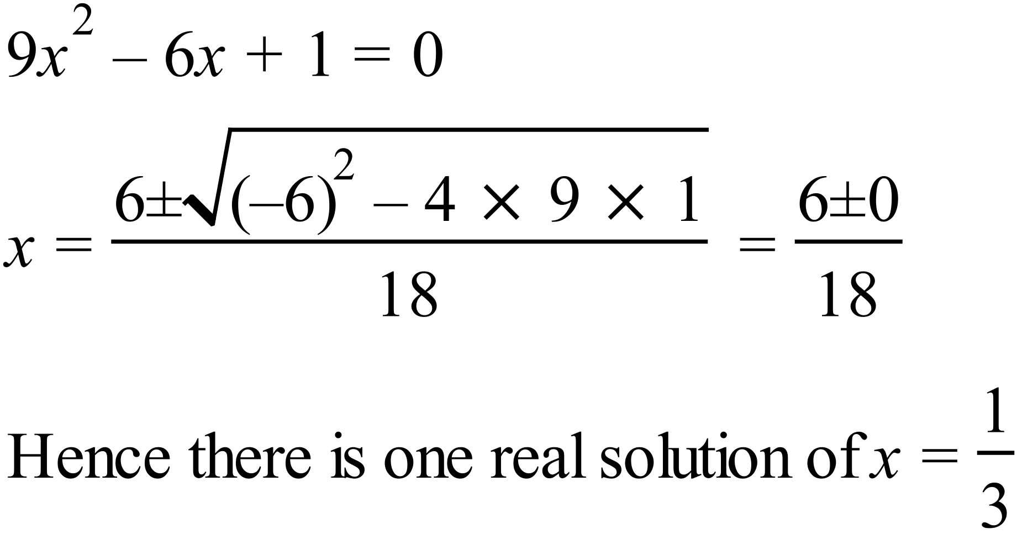  OR  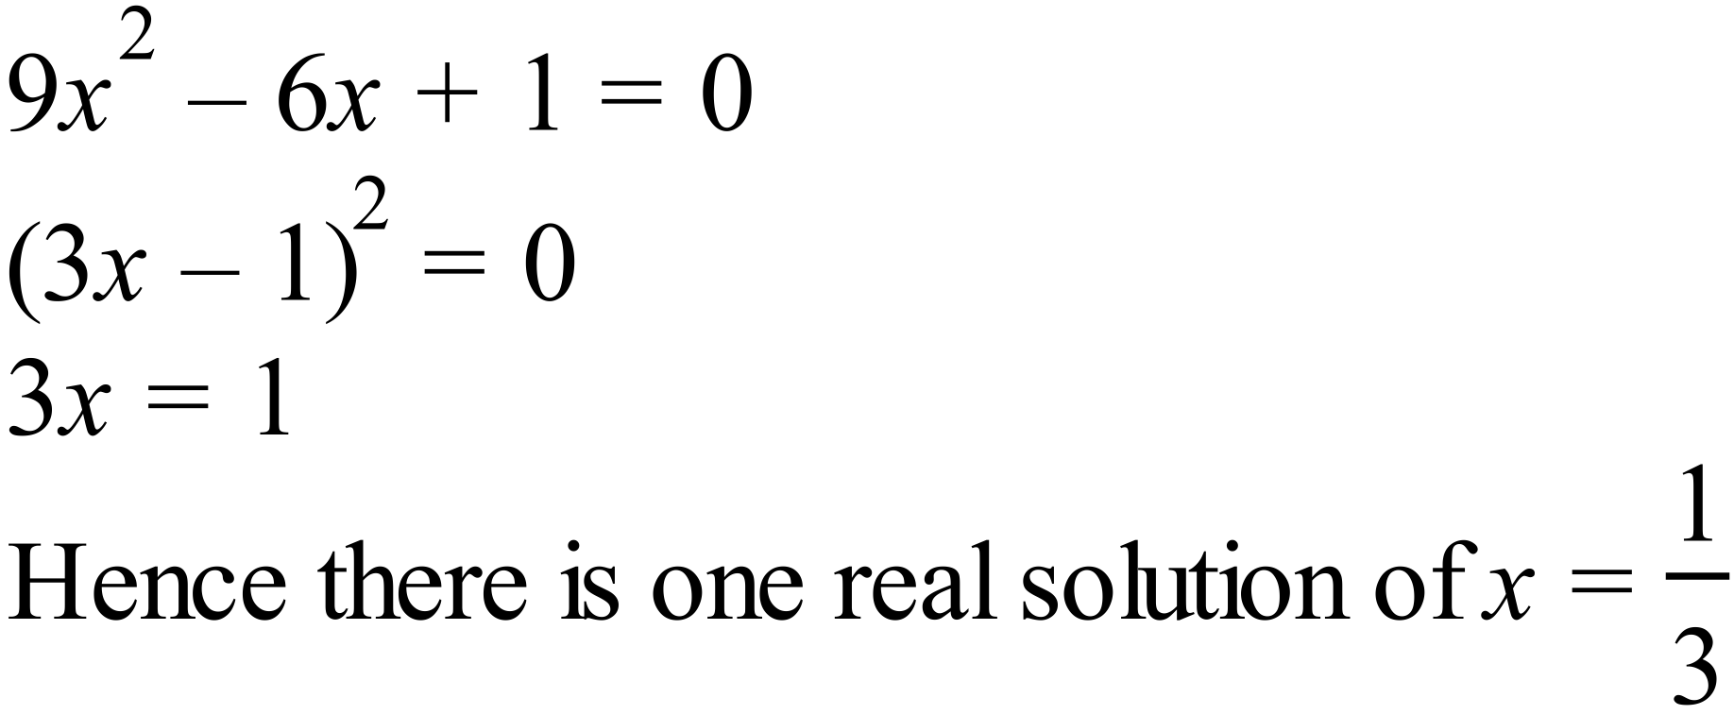 |  | There is one solution.  Need reasoning and working out to receive a mark.
 | 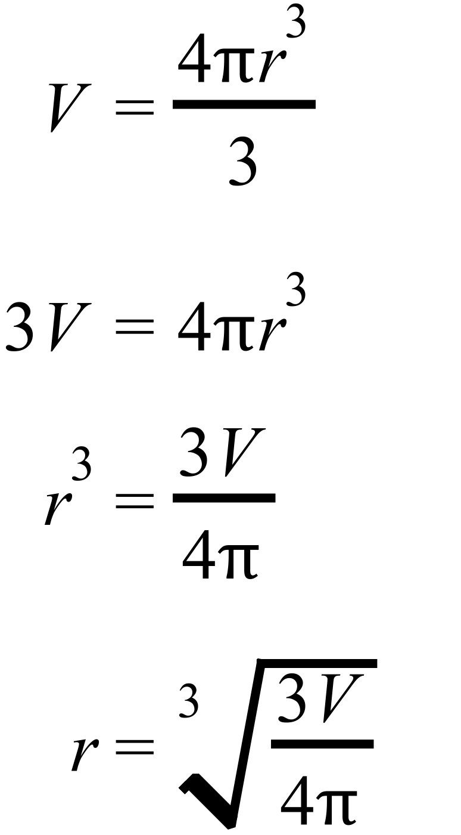 |  | 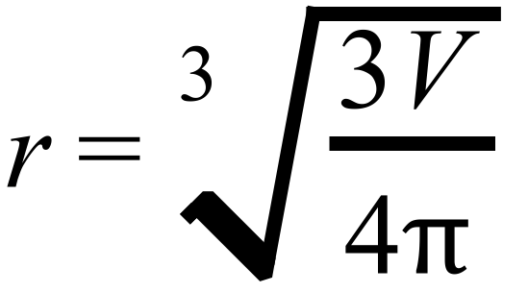

Year 10A |  | Non Linear Equations | Calculator Allowed
Section 2 Multiple Choice Section
ANSWERS
No. | WORKING |  |  | ANSWER
 | 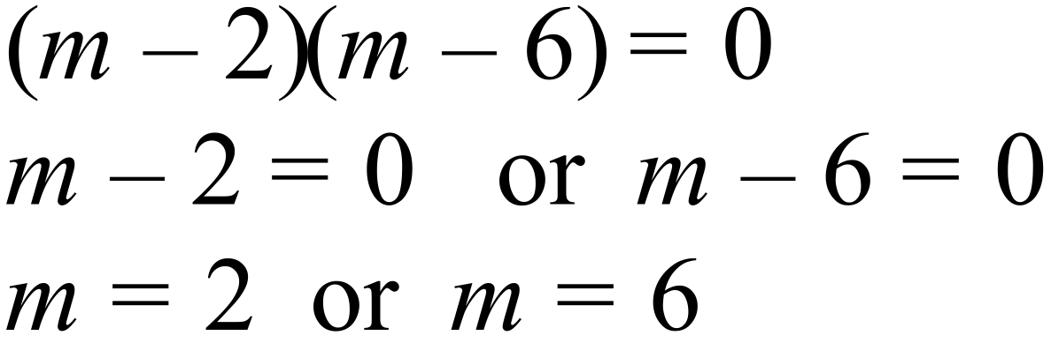 |  |  | D
 | 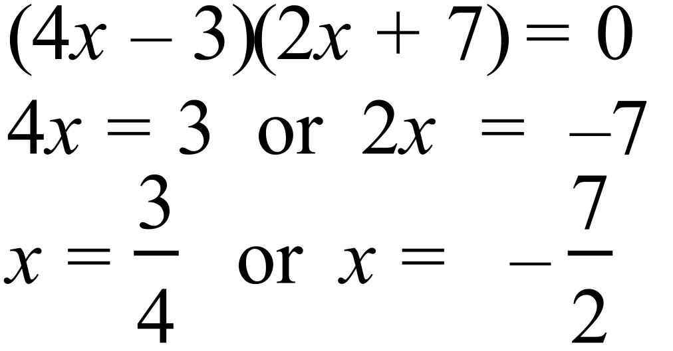 |  |  | C
 | 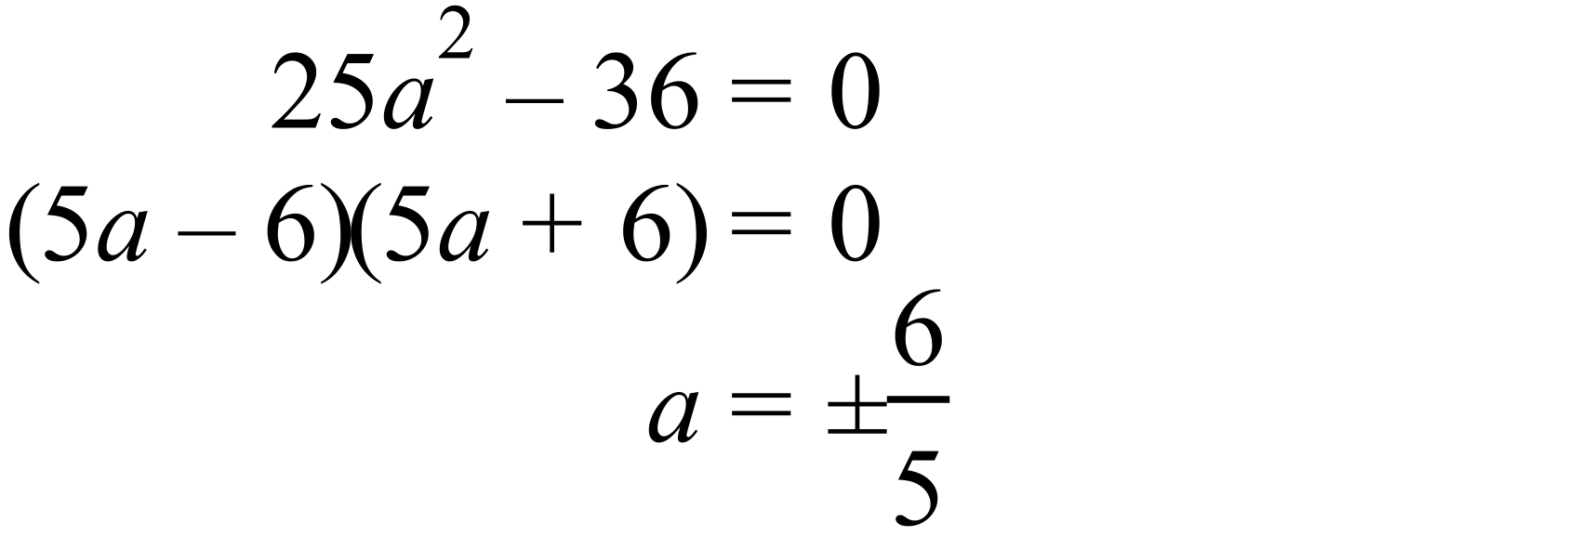 |  |  | A
 | 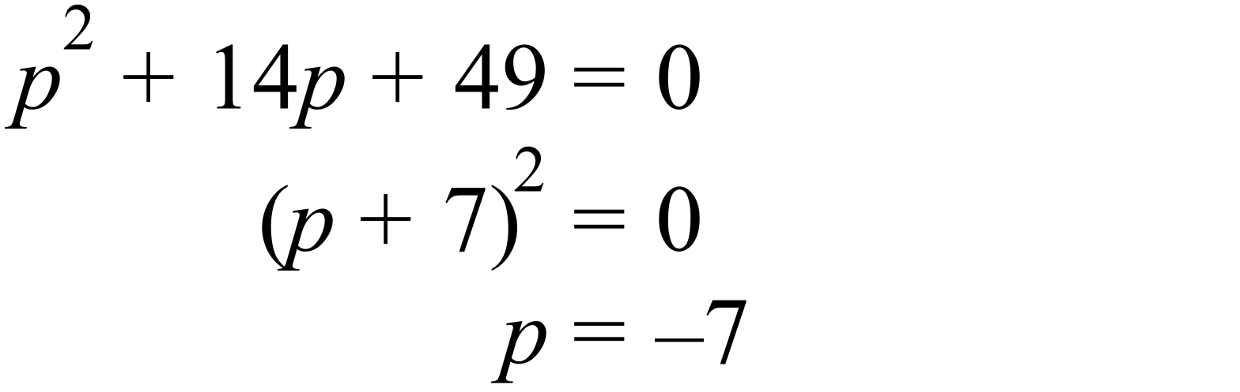 |  |  | C
 | 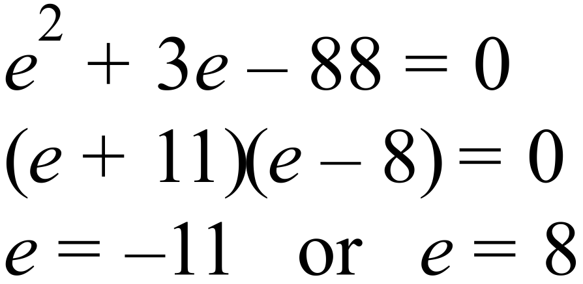 |  |  | B
 | 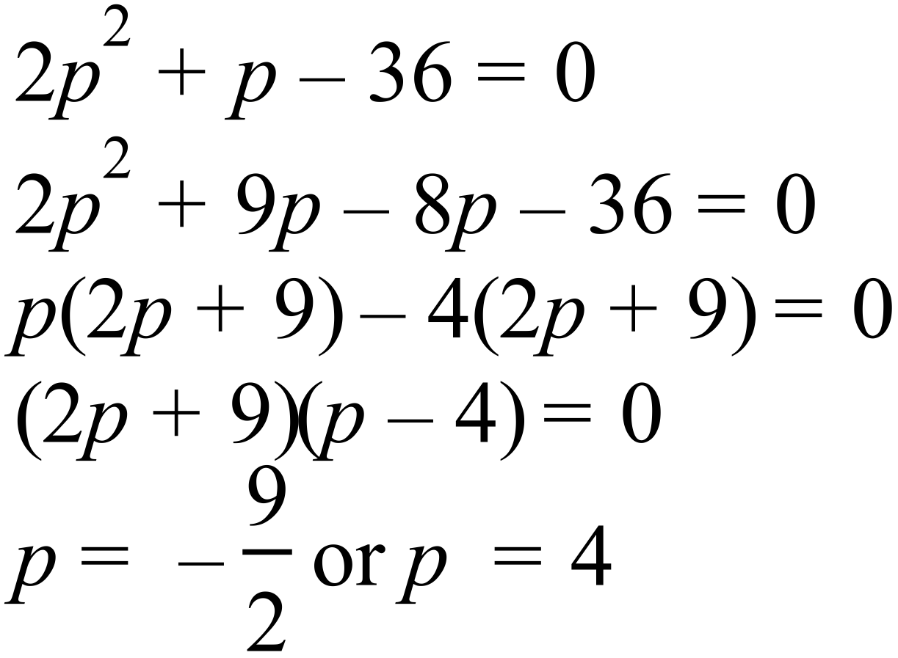 |  |  | D
 | From graph |  |  | C
 | 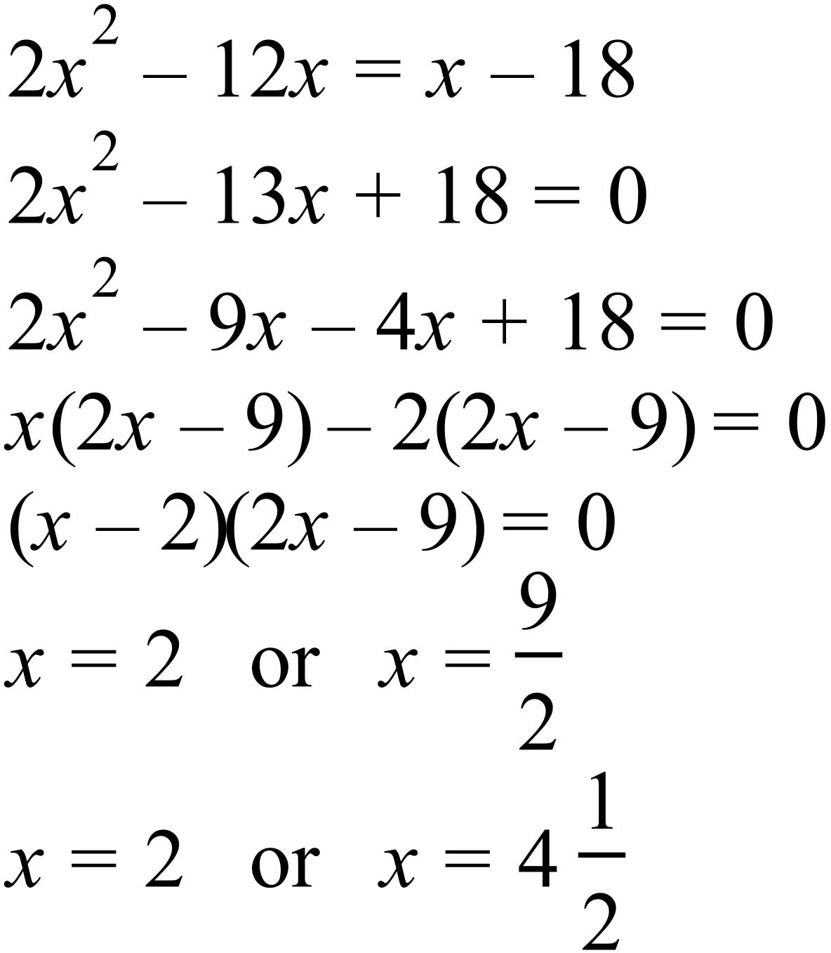 |  |  | D
 | 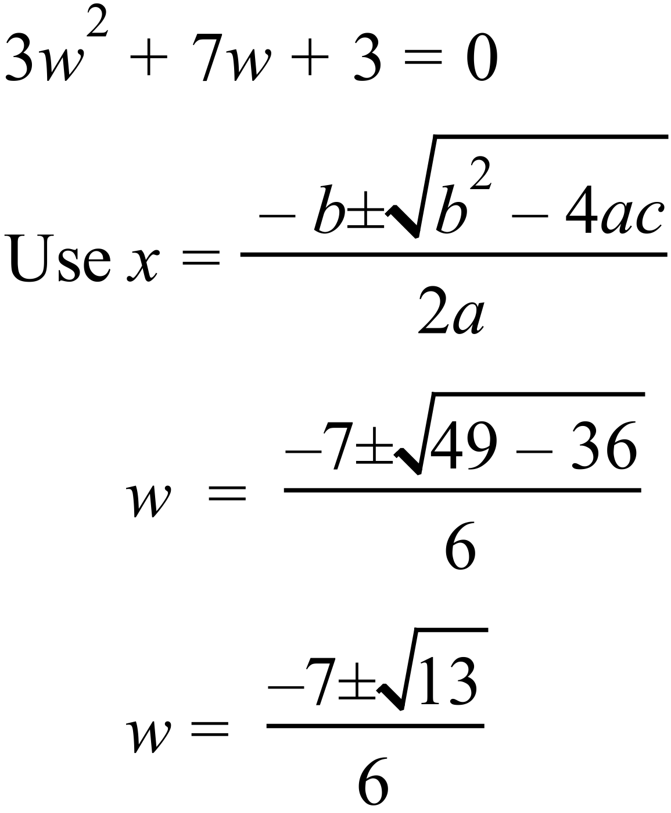 |  |  | A
 | 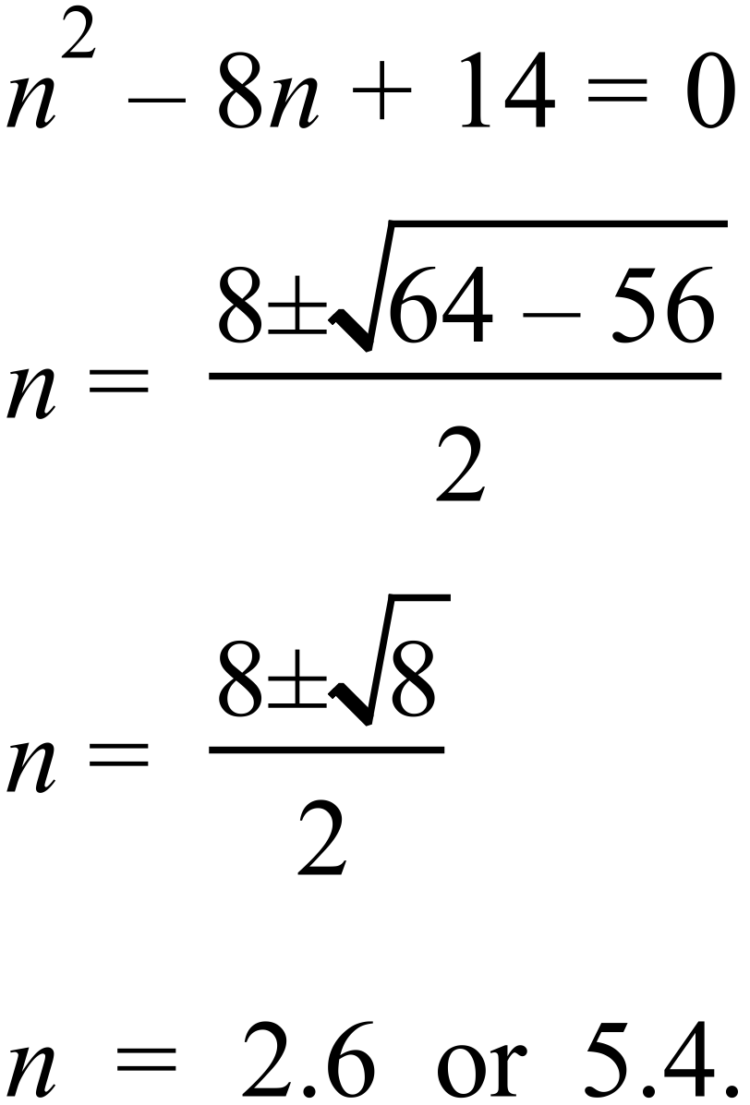 |  |  | B
 | 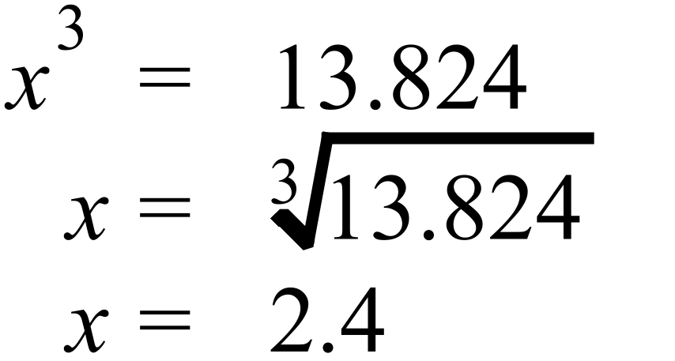 |  |  | B
 | 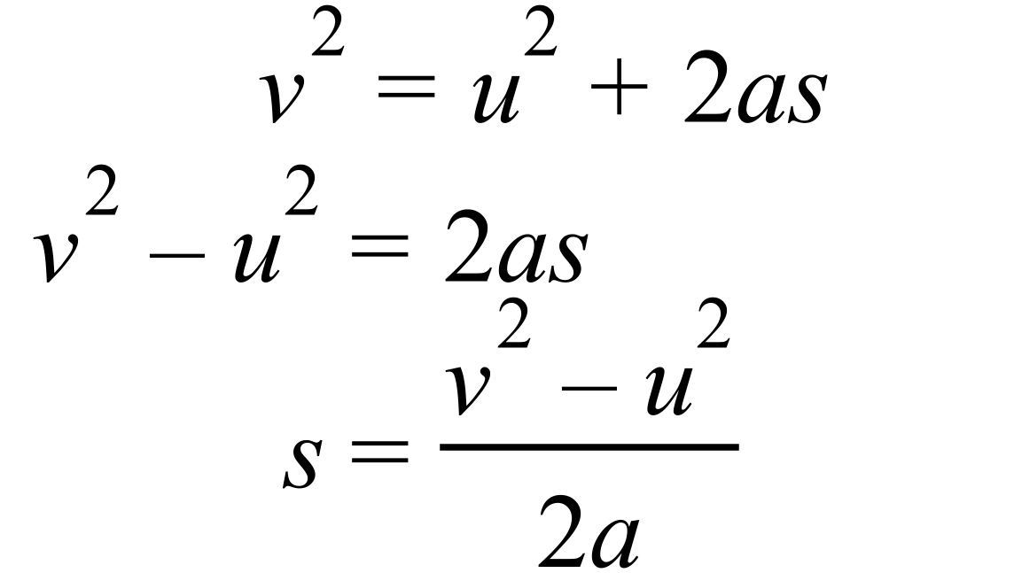 |  |  | A

Multiple Choice Answer Sheet
Non Linear Equations
Name _______ANSWERS_______________________________
Completely fill the response oval representing the most correct answer.

1. A B C D
2. A B C D
3. A B C D
4. A B C D
5. A B C D
6. A B C D
7. A B C D
8. A B C D
9. A B C D
10. A B C D
11. A B C D
12. A B C D
Year 10A |  | Non Linear Equations | Calculator Allowed
Section 3 Longer Answer Section
ANSWERS
 |  |  |  |  | Marks
1. | (a) 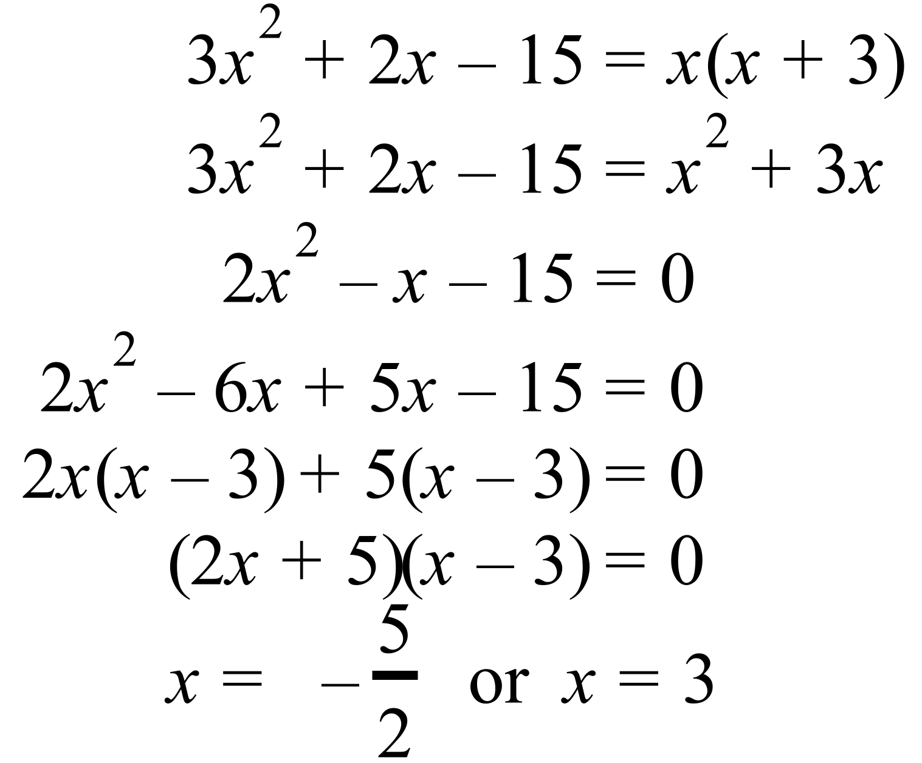 |  |  | 2 marks for correct answers.  1 mark for working with a single error in logic or calculation.
 | (b) 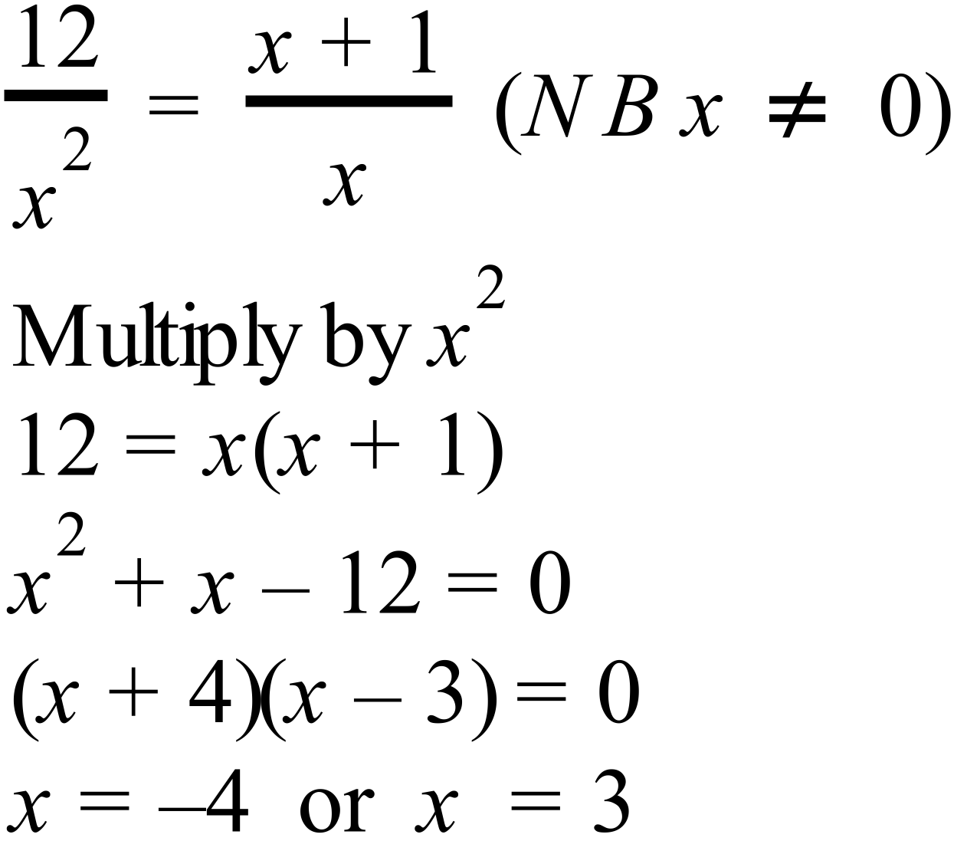 |  |  | 2 marks for correct answers.  1 mark for working with a single error in logic or calculation.
 | (c) i) 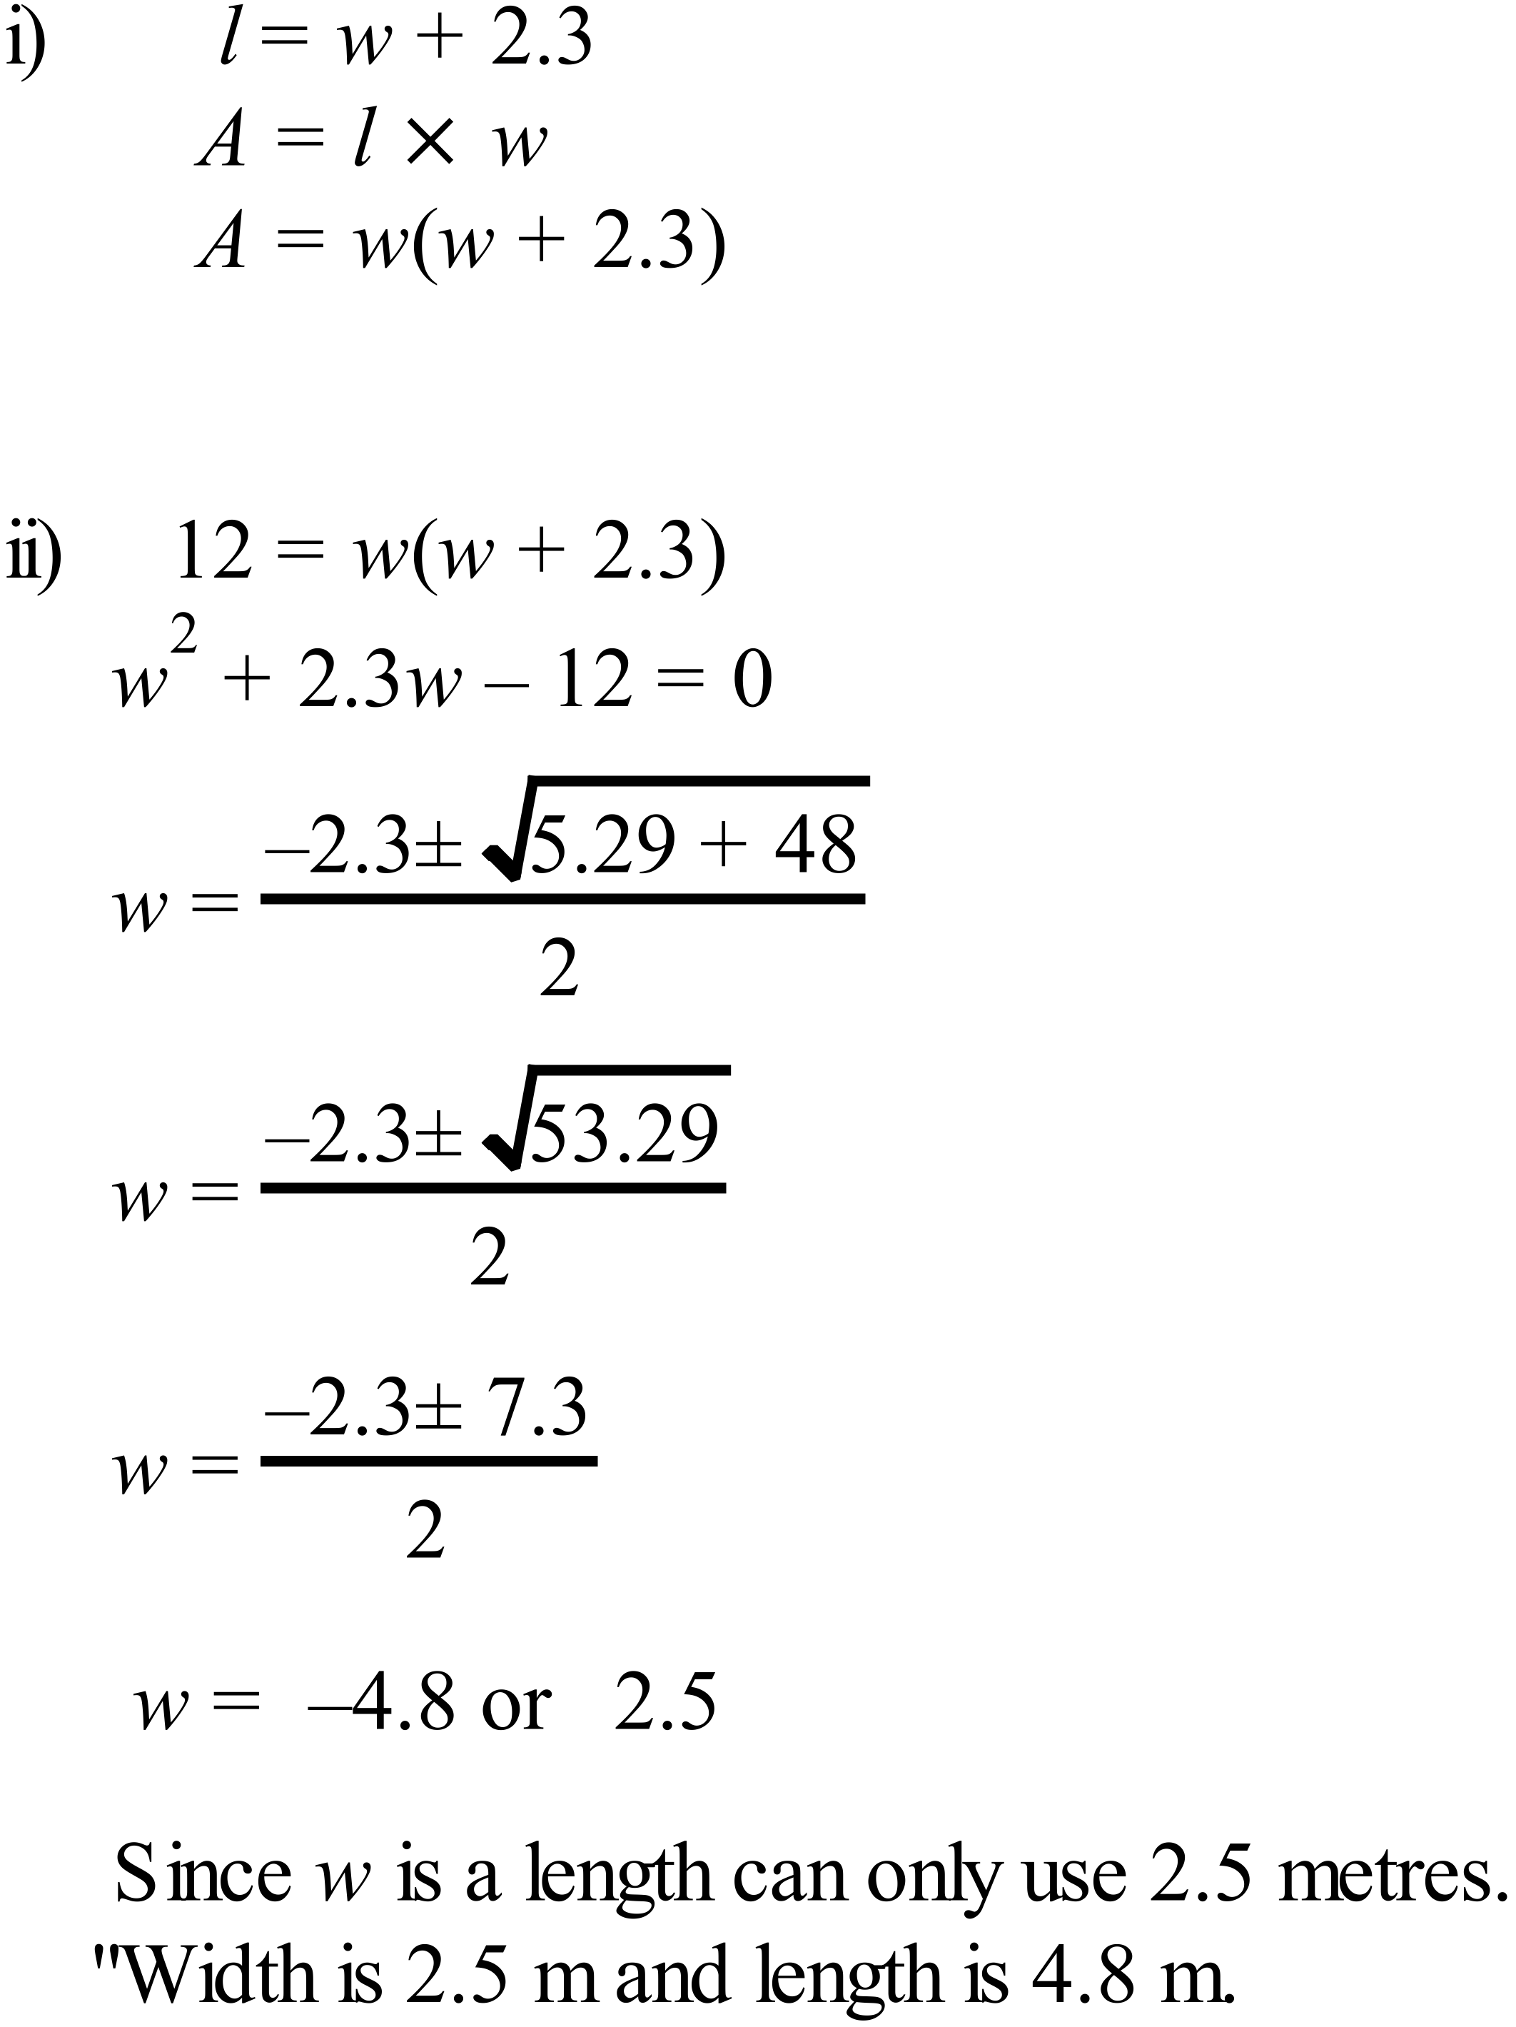 |  |  | 2 marks one for length and 1 for area.  1 mark for setting  area = 12  2 marks for solving correctly  1 mark for attempt at solving which has a minor error
2. | 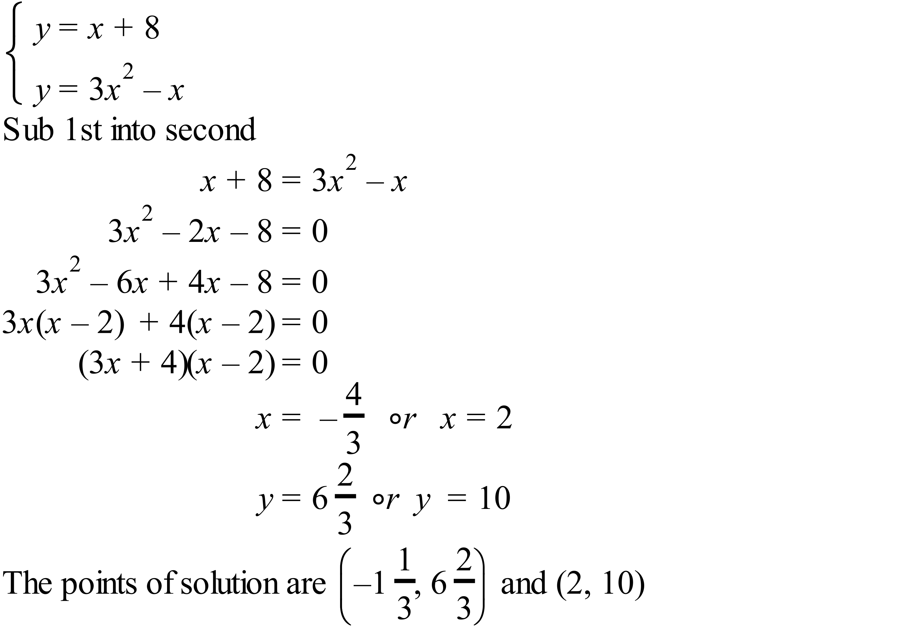 |  |  | 3 marks complete solution which includes substitution to create quadratic equation, solution of quadratic and writing of answers.  2 marks partially correct solution, for example not substituting correctly or not solving the quadratic correctly and writing two answers.  Allocate 1 mark for working that includes some correct reasoning and calculations.

